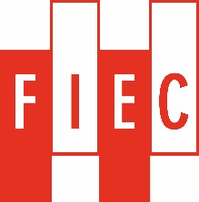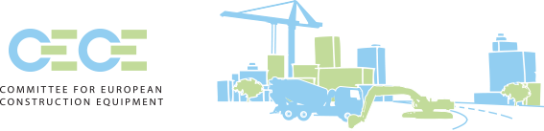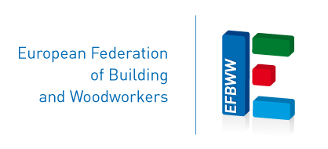



**Project carried out**

**with the financial support of the European Commission**

**Working safer with construction machines**

**A multi stakeholder approach**

**Second Workshop in the offices of EFBWW, Rue Royale 45, 1st floor, Brussels (B),**

**1 December 2016**

**Technology in Transition**

**Healthy and Safe working with Construction Machines**

**09.00 Registration**

9.30 Opening – introduction into the project

*Project Partner (presentation of the joint objectives)*

9.45 Round table – Stakeholder participation in standardization process

*Moderator Pierre PICART*

*KAN, CECE, FIEC, EFBWW*

10.45 Discussion

**11.15 Coffee break**

11.45 The worker voice in standardization

*Stefano BOY*

12.15 The European Commission

*Mr. Viljanen - European Commission – DG Grow*

**13.00 Lunch**

14.30 Standardisation

*Gerhard STEIGER , general secretariat of CEN*

15.00 Program of CEN TC 151

*Kurt HEY, vice chairman of CEN TC 151*

15.30 Final Discussion

16.30 End of the Workshop